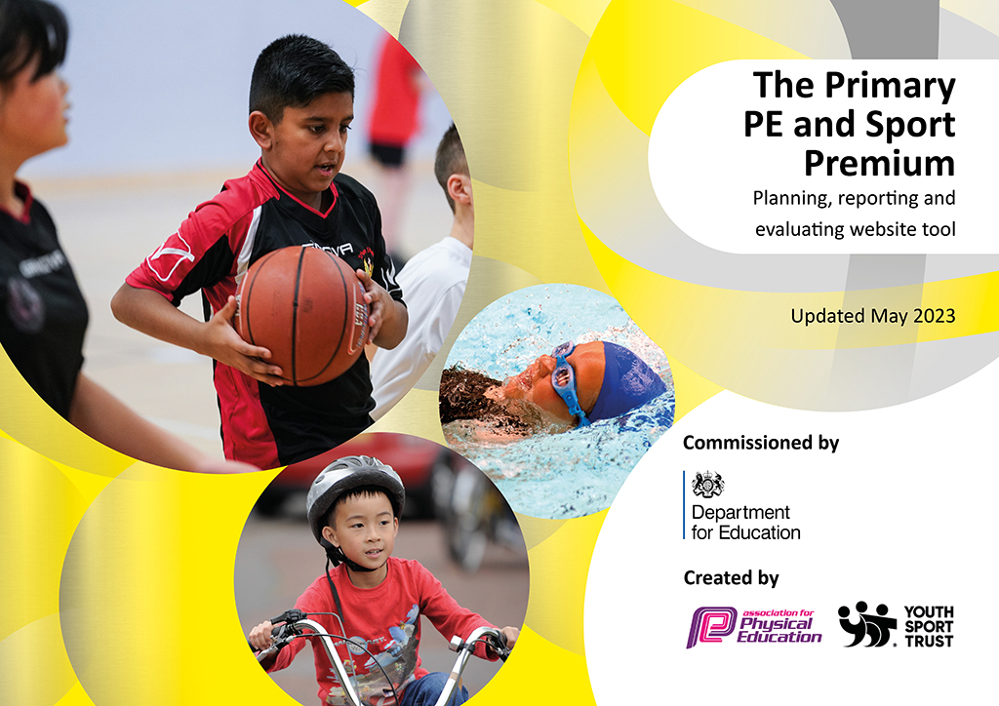
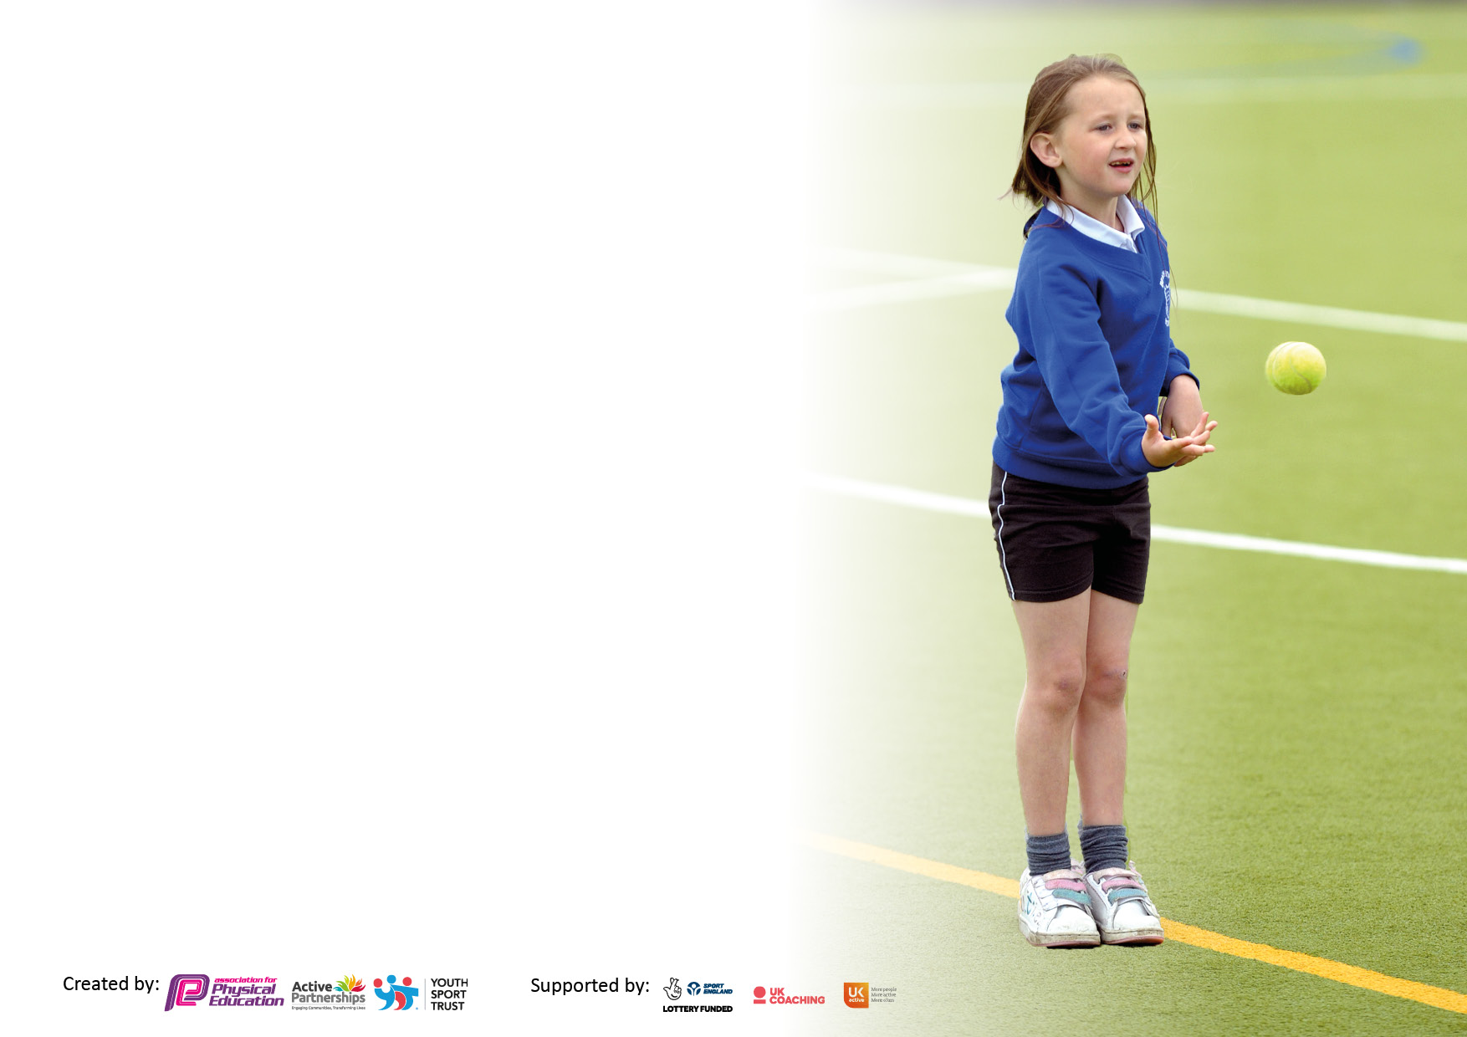

It is important that your grant is used effectively and based on school need. The Education Inspection Framework makes clear there will be a focus on ‘whether leaders and those responsible for governors all understand their respective roles and perform these in a way that enhances the effectiveness of the school’.

Under the Quality of Education judgement, Ofsted inspectors consider:
Intent - Curriculum design, coverage and appropriateness
Implementation - Curriculum delivery, teaching (pedagogy) and assessment
Impact - Attainment and progress

To assist schools with common transferable language, this template has been developed to utilise the same three headings which should make your plans easily transferable between working documents.

Schools must use the funding to make additional and sustainable improvements to the quality of Physical Education, School Sport and Physical Activity (PESSPA) they offer. This means that you should use the Primary PE and sport premium to:

- Develop or add to the PESSPA activities that your school already offers
- Build capacity and capability within the school to ensure that improvements made now will benefit pupils joining the school in future years
- The Primary PE and sport premium should not be used to fund capital spend projects; the school’s budget should fund these.

Please visit https://www.gov.uk/guidance/pe-and-sport-premium-for-primary-schools for the revised DfE guidance, including the 5 key indicators across which schools should demonstrate an improvement. This document will help you to review your provision and to report your spend. DfE encourages schools to use this template as an effective way of meeting the reporting requirements of the Primary PE and Sport Premium.

We recommend you start by reflecting on the impact of current provision and reviewing the previous spend.

Schools are required to publish details of how they spend this funding, including any underspend from 2021/2022, as well as on the impact it has on pupils’ PE and sport participation and attainment.

We recommend regularly updating the table and publishing it on your website throughout the year. This evidences your ongoing self-evaluation of how you are using the funding to secure maximum, sustainable impact. Final copy must be posted on your website by the end of the academic year and no later than the 31 July 2023.

Details with regard to funding
Please complete the table below.

Total amount carried over from 2021/22 | £0
Total amount allocated for 2022/23 | £18,340.00
How much (if any) do you intend to carry over from this total fund into 2023/24? | £0
Total amount allocated for 2022/23 | £18,340.00
Total amount of funding for 2022/23 to be reported on by 31st July 2023 | £18,340.00
Swimming Data
Please report on your Swimming Data below.

Meeting national curriculum requirements for swimming and water safety.

N.B. Complete this section as best you can. For example, you might have practised safe self-rescue techniques on dry land which you can then transfer to the pool when school swimming restarts.
Due to exceptional circumstances priority should be given to ensuring that pupils can perform safe self-rescue even if they do not fully meet the first two requirements of the NC programme of study
What percentage of your current Year 6 cohort swim competently, confidently and proficiently over a distance of at least 25 metres?  N.B. Even though your pupils may swim in another year, please report on their attainment on leaving primary school at the end of the summer term 2023.  Please see note above | 49%
What percentage of your current Year 6 cohort use a range of strokes effectively [for example, front crawl, backstroke and breaststroke]?  Please see note above | 48%
What percentage of your current Year 6 cohort perform safe self-rescue in different water-based situations? | 49%
Schools can choose to use the Primary PE and sport premium to provide additional provision for swimming, but this must be for activity over and above the national curriculum requirements. Have you used it in this way? | No

Action Plan and Budget Tracking
Capture your intended annual spend against the 5 key indicators. Clarify the success criteria and evidence of impact that you intend to measure to evaluate for pupils today and for the future.

Academic Year: 2022/23 | Total fund allocated: | Date Updated:
Key indicator 1: Increase confidence, knowledge and skills of all staff in teaching PE and sport |  |  |  | Percentage of total allocation:
 |  |  |  | %
Intent | Implementation |  | Impact
Your school focus should be clear on what you want the pupils to know and be able to do. What do they need to learn and to consolidate through practice: | Make sure your actions to achieve are linked to your intentions: | Funding allocated: | Evidence of impact:  What do pupils now know and what can they now do? What has changed? | Sustainability and suggested next steps:
To increase the confidence and skills of all staff in teaching PE and sport to ensure lessons are engaging and staff can assess the outcomes of children more effectively. | *Teachers delivering PE sessions from school planning and policy. | ConntedEd (through SHINE Academies) and Walsall LA. | *Teachers within the school have attended PE courses on improving teaching and learning in a variety of activities including:  - PE staff meetings  - PE Co-ordinator meetings  - Primary PE and School Sport Conference  - Trust wide meeting with PE leads. | To continue providing staff with training in and out of school through internal and external providers.  - Soccer Coaching 200  - ConnectEd  - Walsall LA  - Chance to Shine  Staff to lead sporting competitions linked to their clubs.
Key indicator 2: The engagement of all pupils in regular physical activity – Chief Medical Officers’ guidelines recommend that  primary school pupils undertake at least 30 minutes of physical activity a day in school |  |  |  | Percentage of total allocation:
 |  |  |  | %
Intent | Implementation |  | Impact
Your school focus should be clear on what you want the pupils to know and be able to do. What do they need to learn and to consolidate through practice: | Make sure your actions to achieve are linked to your intentions: | Funding allocated: | Evidence of impact:  What do pupils now know and what can they now do? What has changed? | Sustainability and suggested next steps:
To further engagement of all pupils in regular activity so children become more active and participate in regular sporting activities to positively impact those with low physical health and create healthy habits for life beyond primary school. | *Outdoor provision to be developed for break and lunchtime staff.  *Dance specialist to lead dance activities across the school for pupils and team-teach with staff. | £1,500 New equipment.  - Tennis balls  - Bean bags - Hoops - Skipping ropes  - Cones  - Hula Hoops  - Cricket sets  - Footballs  - Netballs  - Tag-Ruby Belts  - Rugby Balls  - Pop-Up Goals  -Hockey Sets | Lunchtime equipment has been purchased to ensure all children have a range of activities to participate in. From this, children have become more active at lunch times and improved the friendship groups of so many as they are able to play with new and existing friends.  PE equipment has been purchased to ensure lessons are resourced and children are engaged. | To introduce Go Noodle to morning routines to get children physically active in the morning before school starts.  To employ the use of a sports apprentice for the next academic tear to lead/support further activities at lunchtimes and after school.  To introduce the use of Cool Kids to improve the fine and gross motor skills of children across the school.  To train and deploy Playground Leaders for the next academic year.

Key indicator 3: The profile of PE and sport is raised across the school as a tool for whole school improvement |  |  |  | Percentage of total allocation:
 |  |  |  | %
Intent | Implementation |  | Impact
Your school focus should be clear on what you want the pupils to know and be able to do. What do they need to learn and to consolidate through practice: | Make sure your actions to achieve are linked to your intentions: | Funding allocated: | Evidence of impact:  What do pupils now know and what can they now do? What has  changed? | Sustainability and suggested next steps:
To develop a healthy living lifestyle within school through fitness sessions within the curriculum, healthy eating at break and lunch times and how activities outside the curriculum can support a healthy lifestyle. | *Develop a range of clubs that discuss and emphasis the importance of developing fitness and healthy lifestyles. | £150 per term for clubs to bring in new equipment to support with an engaging club. | *Emphasis on healthy snacks during break and lunchtimes with fruit available for KS1 children at break time and fruit and salad bar available for all children at lunchtime.  *Extra-curricular clubs on offer were more practical and engaging for children to be more physical. | Clubs to continue next year and build on the emphasis of making them active and engaging for all children.  30-minute fitness lessons (1 per week).
Key indicator 4: Broader experience of a range of sports and physical activities offered to all pupils |  |  |  | Percentage of total allocation:
Intent | Implementation |  | Impact
Your school focus should be clear on what you want the pupils to know and be able to do. What do they need to learn and to consolidate through practice: | Make sure your actions to achieve are linked to your intentions: | Funding allocated: | Evidence of impact:  What do pupils now know and what can they now do? What has  changed? | Sustainability and suggested next steps:
Broader experience of a range of sports and activities offered to all pupils so they are able to develop their skills and knowledge.  To continue to provide teaching and learning in swimming for children in Year 6. | *New clubs offered.  Continue to take advantage of local sports clubs, activities and offers.  *New equipment outdoors.  *Pupil Survey to ascertain what club’s pupils would like and try to include in the after school programme so that as many pupils as possible are engaged in regular physical activity (target those who did not attend a club in 2018-2019).  *Research other opportunities for pupils to attend taster sessions for other more unusual activities locally provided (surfing, horse riding, tree climbing).  *For all children in Year 6 to attend termly swimming lessons.  *For a high % of Year 6 children to swim 25m or further by the end of the year, | £1,525 New equipment  Specific Sports  - Footballs  - Ball pump  - Netballs  - Netball hoops  - Basketballs  - Basketball hoops  - Cricket sets  £10,000 – pool hire and staffing.  Transport - £3000 | Children have had a wide range and variety of equipment to play with outdoors during lunchtimes to encourage them to become more physically active.  Engagement within PE lessons has risen due to the higher volume of equipment children have to use and staff have commented on how smoothly lessons are now running with children being more active and willing to participate.  Bloxwich Academy used as pool provider with external swimming teacher providing the lesson content. | To increase the participation of children attending clubs and raising the attainment of physical activities.  Increase the number of events/competitions participated in.  To introduce specialist coaches to support more able children and allow class teachers to develop own CPD by observing (Chance to Shine & Soccer Coaching 2000).  To continue swimming for all Year 6 children for the next academic year.  For a higher % of Y6 children to achieve 25m or more by the end of the year.

Key indicator 5: Increased participation in competitive sport |  |  |  | Percentage of total allocation:
 |  |  |  | %
Intent | Implementation |  | Impact
Your school focus should be clear on what you want the pupils to know and be able to do. What do they need to learn and to consolidate through practice: | Make sure your actions to achieve are linked to your intentions: | Funding allocated: | Evidence of impact:  What do pupils now know and what can they now do? What has  changed? | Sustainability and suggested next steps:
To increase participation within competitions so all children have the opportunity to participate in a competition setting. | *To build links with local schools to run competitions across a range of schools.  *To run inter-house tournaments each half term for all children to participate in.  *To participate in termly trust wide competitions. | £150 for trophies to celebrate children’s achievements,  £150 for Sports Day trophies. | Children have had the opportunity to participate in sports throughout the year.  Children have been able to develop their understanding of certain sports and use a range of skills they have been taught. | To continue celebrating the success of children next academic year with rewards, certificates, trophies and assemblies.

Signed off by
Head Teacher: | Mrs. N Bayliss
Date: | 19.07.23
Subject Leader: | Mr. J Dee
Date: | 19.07.23
Governor:
Date:

